<https://itnext.io/azure-paas-data-storage-solutions-when-to-use-what-9a70bf077004>



We are living in a world where a lot of data is generated in all shapes and sizes and can be used for a different purpose. Management and store of such data at scale is a challenge.

Fortunately, Azure has a rich collection of data-based offerings. In this article, I will summarize the Azure data storage solutions available as PaaS offering and their ideal use cases.

**Data Storage options in Azure PaaS**

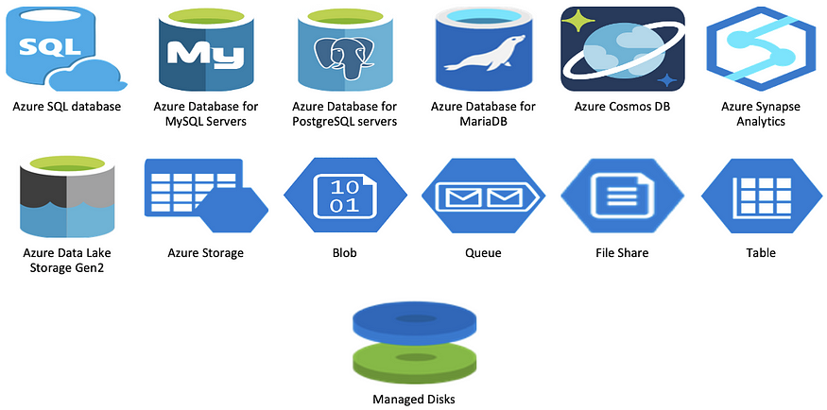

Blob, Queue, File, Table and Managed Disk are offered under **Azure Storage**. But since they all store/hold data, I have included them in this list.

For Simplicity I am going to divide these services into 3 categories:

1. Relational Data

2. Unstructured/document data

3. Big data & Analytics

**Relational Data**

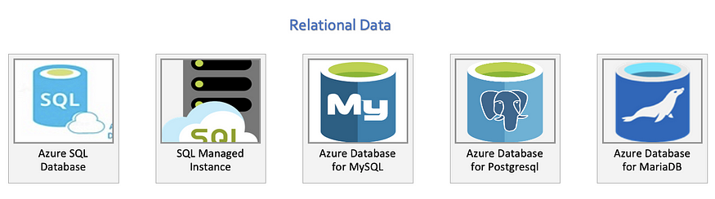

**Unstructured/document data**

**Big Data & Analytics**

**Summary — When to Use What**

* OLTP - Online Transactional Processing

**OLAP - Online Analytical Processing

SQL Server database and SQL Managed Instance are two separate offerings, but they share same features.

Storage account has multiple services offered. I have created a separate Feature set to compare against Storage Account Service Offerings.

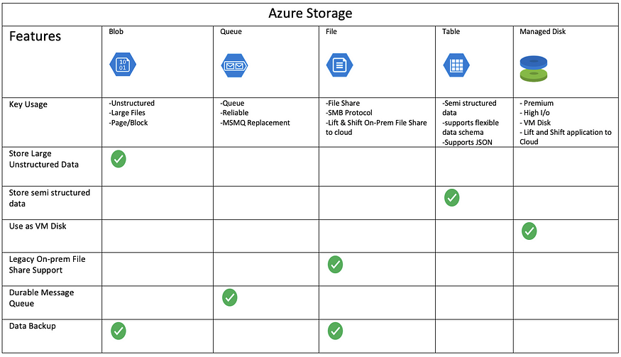

## **Microsoft Azure DP 900 Data Fundamentals**

<https://art-verse.com/microsoft-azure-resources-cheat-sheets-free-pdf-downloads/>

Here is a list of links to the current sheets:

1. [**Data Concepts Cheat Sheet #1**](https://art-verse.com/2022/01/22/microsoft-azure-data-fundamentals-dp-900-data-concepts-cheat-sheet-1-free-download/)
2. [**Databases Cheat Sheet #2**](https://art-verse.com/2022/02/19/microsoft-azure-data-fundamentals-dp-900-data-concepts-cheat-sheet-2-free-download/)
3. [**Data Processing Cheat Sheet #3**](https://art-verse.com/2022/04/23/microsoft-azure-data-fundamentals-dp-900-data-processing-cheat-sheet-3-free-download/)
4. [**Data Professionals Cheat Sheet #4**](https://art-verse.com/2022/05/28/microsoft-azure-data-fundamentals-dp-900-data-professionals-cheat-sheet-4-free-download/)
5. [**Data Services Cheat Sheet #5**](https://art-verse.com/2022/07/30/microsoft-azure-data-fundamentals-dp-900-data-services-cheat-sheet-5-free-download/)
6. [**SQL Database Cheat Sheet #6**](https://art-verse.com/2022/08/27/microsoft-azure-data-fundamentals-dp-900-sql-database-cheat-sheet-6-free-download/)
7. [**SQL Managed Instance Cheat Sheet #7**](https://art-verse.com/2022/10/29/microsoft-azure-data-fundamentals-dp-900-sql-managed-instance-cheat-sheet-7-free-download/)
8. [**Other Databases Cheat Sheet #8**](https://art-verse.com/2022/11/26/microsoft-azure-data-fundamentals-dp-900-other-databases-cheat-sheet-8-free-download/)
9. [**Provisioning Services Cheat Sheet #9**](https://art-verse.com/2023/01/28/microsoft-azure-data-fundamentals-dp-900-provisioning-services-cheat-sheet-9-free-download/)
10. [**Firewalls & Connectivity Cheat Sheet #10**](https://art-verse.com/2023/02/25/microsoft-azure-data-fundamentals-dp-900-firewalls-and-connectivity-cheat-sheet-10-free-download/)
11. [**Table Storage Cheat Sheet #11**](https://art-verse.com/2023/03/25/microsoft-azure-data-fundamentals-dp-900-table-storage-cheat-sheet-11-free-download/)
12. [**Blob Storage Cheat Sheet #12**](https://art-verse.com/2023/04/22/microsoft-azure-data-fundamentals-dp-900-blob-storage-cheat-sheet-12-free-download/)
13. [**File Storage Cheat Sheet #13**](https://art-verse.com/2023/07/15/microsoft-azure-data-fundamentals-dp-900-file-storage-cheat-sheet-13-free-download/)
14. [**Data Warehousing Cheat Sheet #14**](https://anddnasci.wordpress.com/2023/07/29/microsoft-azure-data-fundamentals-dp-900-data-warehousing-cheat-sheet-2-free-download/)
15. [**Cosmos DB Cheat Sheet #15**](https://art-verse.com/2023/08/19/microsoft-azure-data-fundamentals-dp-900-cosmos-db-cheat-sheet-15-free-download/)
16. [**Data Factory Cheat Sheet #16**](https://art-verse.com/2023/09/16/microsoft-azure-data-fundamentals-dp-900-data-factory-cheat-sheet-16-free-download/)
17. [**Data Services Cheat Sheet #17**](https://art-verse.com/2023/09/30/microsoft-azure-data-fundamentals-dp-900-data-services-cheat-sheet-17-free-download/)
18. [**Databricks Cheat Sheet #18**](https://art-verse.com/2023/10/21/microsoft-azure-data-fundamentals-dp-900-databricks-cheat-sheet-18-free-download/)

## Microsoft Azure AZ 900 CLOUD Fundamentals

1. [**Cloud Computing Cheat Sheet #1**](https://art-verse.com/2021/01/16/microsoft-azure-900-fundamentals-cloud-computing-cheat-sheet-1-free-download/)
2. [**Architectural Components Cheat Sheet #2**](https://art-verse.com/2021/02/20/microsoft-azure-900-fundamentals-architectural-components-cheat-sheet-2-free-download/)
3. [**Compute Services Cheat Sheet #3**](https://art-verse.com/2021/03/20/microsoft-azure-900-fundamentals-compute-services-cheat-sheet-3-free-download/)
4. [**Container Services Cheat Sheet #4**](https://art-verse.com/2021/04/17/microsoft-azure-900-fundamentals-container-services-cheat-sheet-4-free-download/)
5. [**Network Services Cheat Sheet #5**](https://art-verse.com/2021/05/15/microsoft-azure-900-fundamentals-network-services-cheat-sheet-5-free-download/)
6. [**Storage Services Cheat Sheet #6**](https://art-verse.com/2021/06/12/microsoft-azure-900-fundamentals-storage-services-cheat-sheet-6-free-download/)
7. [**Database Services Cheat Sheet #7**](https://art-verse.com/2021/07/10/microsoft-azure-900-fundamentals-database-services-cheat-sheet-7-free-download/)
8. [**IoT Services Cheat Sheet #8**](https://art-verse.com/2021/08/14/microsoft-azure-900-fundamentals-iot-services-cheat-sheet-8-free-download/)
9. [**Analytics Services Cheat Sheet #9**](https://art-verse.com/2021/09/11/microsoft-azure-900-fundamentals-analytics-services-cheat-sheet-9-free-download/)
10. [**AI Services Cheat Sheet #10**](https://anddnasci.wordpress.com/2021/10/09/microsoft-azure-900-fundamentals-ai-services-cheat-sheet-10-free-download/)
11. [**Serverless Computing Services Cheat Sheet #11**](https://art-verse.com/2021/11/13/microsoft-azure-900-fundamentals-ai-services-cheat-sheet-10-free-download-2/)
12. [**DevOps Services Cheat Sheet #12**](https://art-verse.com/2021/12/11/microsoft-azure-900-fundamentals-devops-cheat-sheet-12-free-download/)
13. [**App Services Cheat Sheet #13**](https://art-verse.com/2023/04/01/microsoft-azure-900-fundamentals-app-services-cheat-sheet-13-free-download/)
14. [**Management Tools Cheat Sheet #14**](https://art-verse.com/2023/05/01/microsoft-azure-900-fundamentals-management-tools-cheat-sheet-14-free-download/)
15. [**Network Security Services Cheat Sheet #15**](https://art-verse.com/2023/06/03/microsoft-azure-900-fundamentals-network-security-cheat-sheet-15-free-download/)
16. [**Authentication Authorization Cheat Sheet #16**](https://art-verse.com/2023/07/01/microsoft-azure-900-fundamentals-authentication-authorization-services-cheat-sheet-16-free-download/)
17. [**Security Tools & Services Cheat Sheet #17**](https://art-verse.com/2023/08/14/microsoft-azure-900-fundamentals-security-tools-services-cheat-sheet-17-free-download/)
18. [**Data Governance Services Cheat Sheet #18**](https://art-verse.com/2023/09/02/microsoft-azure-900-fundamentals-data-governance-services-cheat-sheet-18-free-download/)
19. [**Monitoring & Reporting Cheat Sheet #19**](https://art-verse.com/2023/10/07/microsoft-azure-900-fundamentals-monitoring-and-reporting-services-cheat-sheet-19-free-download/)